

Department of Industrial and Systems Engineering

Indian Institute of Technology, Kharagpur

Sub: Simulation Lab(IM39006) Project Report

Flight Diversion Strategy In Fog-Hit Delhi

Group No. 6
Date of Submission : 29/3/2022

NAME | ROLL NUMBER | CONTRIBUTION
Satyam Gupta | 19IM10027 | Collection of Airports Data , Model Design
Shashank Sundi | 19IM10028 | Model Design, Simulation Model and Solution Analysis
Shivam Pandey | 19IM10029 | Model Design, Solution Analysis
Srinjayee Paul | 19IM10030 | Model Design, Research on Diversion Strategies
Stuti Parmar | 19IM10031 | Research on Diversion Strategies and Flight Processing Research

Problem Statement
During the winter season there is a huge fog situation in Delhi due to which flights could not land in the Delhi Airport. The Airport authority has decided to divert the flights to other nearby Airports. Create a Simulation model and simulate the airport operations and record arrival times for comparison.

Introduction
Our project deals with airlines’ diversion management, which entails a complex decision-making process that comes into action during adverse events, preventing the execution of the regular flight operations. Diverting from the intended route can be caused by several reasons, the most frequent of which are: repugnant weather that prohibits aircraft from taking off and landing, medical emergencies or technical faults such as Unexpected aircraft delays, Maintenance problems of aircraft, Crew unavailability. A flight diversion can severely disrupt the passenger’s comfort, jeopardize the fleet or the crew planning and is generally accompanied with significant expenses. The intention of every airline in the case of a diversion is to assure the fastest turnaround time and/or provide the passengers with the highest level of services to mitigate the negative effects. A wrong selection of an alternate airport that is not having enough capacity, personnel or material resources to handle a flight diversion in a timely manner can negatively influence the airline in several ways. Both strategic and tactical diversion management process is a collaborative decision-making procedure, heavily dependent on the base of the information available, where the main actors are not only flight crew and the airline Operational Control Center but also the Air Traffic Controller, airport operators and the local service providers.

Occurrence of fog during late night or early morning over the northern plains of India is common in winter. Fog is defined as an obscurity near the surface layer of the atmosphere which is caused by a suspension of water droplets and is associated with visibility less than 1000 m. More than 900 aircrafts on an average depart and arrive daily from Indira Gandhi International (IGI) Airport,New Delhi, with the maximum number at night and morning hours when chances of dense fog are high during the peak winter months of december and january; due to this many flights are either cancelled or diverted. Due to the availability of only one full-time run way (RW-28) during low visibility period because of fog,air traffic operation over IGI further aggravates, with high holding period and severe
congestion.Also,IGI is one of India’s airports where sophisticated CAT-III ILS has been installed to assist pilots to operate aircraft under dense fog condition with visibility up to 50 m but still the need for diversion to alternate airports comes into play.

Strategies to choose diversion airport:

There is no given methodology for the diversion airport selection that would be determining and mandating to use the alternate airport as per given set of hard rules. Therefore, for every flight a flight planner can select an alternate airport as per the current requirements of dedicated flight or preferences of the airline operator. Especially for small airlines, only basic characteristics of the airport are examined such as the opening hours and physical characteristics. As a best practice, various factors playing a role in the diversion location selection are evaluated and can be divided into two groups:

Basic factors (determining if an aircraft can land on an airport):

- Airport operational, physical and technical characteristics to accept the aircraft type at given time (runway length, equipment, opening hours, curfews etc.)
- Weather conditions

- Distance from the intended route and destination (fuel planning)

- Other (pilot licenses, etc.)

Commercial factors (influencing the diversion recovery):

- Relative proximity of the diversion location as a passenger wellbeing factor

- Level of airport infrastructure (airport size)

- Airline’s own infrastructure (own or contracted airline staff present on the location)

- Existence of agreements with the handlers, fueler and other stakeholders

- Experiences with the given location

- Other commercially important and detailed factors (hotels availability, transportation possibilities, etc.)

Based on the evaluation of the above, the flight planner decides about the alternate locations, files them in the flight plan and provides them to the crew at the time of the pre-flight briefing. At least two scenarios consequent to the diversion landing shall be assessed:

- Technical stop - the aircraft is refueled and dispatched as soon as possible, the passengers are often remaining on board

- Full termination of the flight – when an aircraft is forced to stay on the diversion airport for an extended period of time.

Diversion Risk Index :

The airport diversion risk index is a new proposed attribute that is assigned to the aircrafts that were unable to land in Delhi Airport. The flights choose the alternate airport to land , based on the Risk Diversion Index (DRI) and other constraints like Runway Utilization, Available Parking Space at airport, etc.
There are many scenarios that determine how long an airplane will be delayed in an event of a diversion and many elements that do play a role in the delay estimation. The most important factors contributing to the delays that need to be looked at, are mostly associated with ground resources availability. As the evaluation of all the ground resources in a diversion event might be complicated, it is beneficial to assign every flight with the current Risk Diversion Index (DRI) based on the possible impact it might have on landing on any of the alternate airports. This index shall be used as a standard across the network to ensure consistency and credibility of calculated values based on which ultimate tactical decisions are made.
RDI is calculated for each airport and assigned to the flight. The flight diverts its route to the airport with least RDI .

RDI Formula:
RDI = 1/(c + available flight parking spaces – parking spaces in use )
c = constant added to avoid zero division error

Processing a Flight at an Airport:

After the alternate airport for diversion is selected, the flight is rerouted to the destined airport for Landing.

The nearby Airports for Delhi where the flights can be diverted are:

- Jaipur
- Dehradun
- Chandigarh

Jaipur Airport has two runways , whereas Dehradun and Chandigarh have a single runway.
Only one flight can land at a time and there must also be a minimum time interval between two landing so that the flights can make way to the Taxiway for deboarding and further procedures which is expected to be around 3-5 minutes.

The actions taken after landing and shifting the flights to the bays at the airport are as follows:
- De-boarding of Passengers: Passengers move out of the aircraft with their possessions.
- Maintenance Checks: The inside of the aircraft undergoes maintenance checks by the crew members
- Plan Approval by Authorities: The pilot on discussing with the airline cites a plan and submits it to authorities at the airport for approval for the next destination.
- Refuelling: The aircraft is refuelled for the next flight depending on the plan approved and next destination.
- Technical Inspection: The pilot checks for damages on the body of the aircraft to judge if the aircraft is suitable for take-off. Also change of crew takes place during this period.

 | Jaipur | Dehradun | Chandigarh | Delhi
Number of landings | 68 | 36 | 54 | 780
per day
Average time | 19 | 30 | 25 | 10
interval between
two flights(min)
Runways | 2 | 1 | 1
 |  |  |  | 3
The above processes generally take place simultaneously to reduce time spent on ground by the aircraft for commercial benefits. These processes along with onboarding combined take about 20 to 45 mins on the airport before departure to the next destination. The onboarding in parking spot can be longer or shorted , depending on the business of the airport.

Collected Relevant Data

MODEL:

We create a model for Delhi airport and all alternative airports simulating the different processes at the airport including the actual runways and parking space. According to the strategies discussed above , the priority of new destination is chosen based on divergence risk index, utilization of runways and capacity to accommodate or park aircrafts. In our model, we run the simulation and based on the results we devise the optimal strategy. The objective is to decide the best strategy to follow to enable route diversion while considering minimisation of delay and wait times.

Data Obtained:

The data obtained from the internet suggests that the Landing process takes 1-5 minutes, so we use the triangular distribution TRIA(1,3,5) minutes for the process. As the capacity for landing is different for different airports we change the resource capacity accordingly. We combine the de-boarding, Refuelling, Technical inspection, On-boarding etc. process which take place at Bays of the Airport as a single process. This estimate is taken from the data found on the various websites related to aviation.
Delhi Airport is the busiest airport in India. From amongst the alternate airports , Jaipur is the busiest , followed by Chandigarh and Dehradun

Jaipur Airport : 1 runway , Parking Capacity – 15 , Emergency Landing Capacity – 7 Inter-arrival time – TRIA(20,35,40) , Parking / Maintainance time – TRIA(20,25,30) ,
Time for Arrival or Departure on runway – TRIA(1,3,5) minutes

Chandigarh Airport : 1 runway , Parking Capacity – 15 , Emergency Landing Capacity – 7
Inter-arrival time – TRIA(20,40,60) , Parking / Maintainance time – TRIA(20,30,40) ,
Time for Arrival or Departure on runway – TRIA(1,3,5) minutes

Dehradun Airport : 1 runway, Parking Capacity – 10, Emergency Landing Capacity – 5
Inter-arrival time – TRIA(30,40,60) , Parking / Maintainance time – TRIA(20,30,40) ,
Time for Arrival or Departure on runway – TRIA(1,3,5) minutes

Objective:

- Analyzing the proposed initial strategy for

- Finding an optimal preference policy of airports for diversion.

Assumption : Most of the flights going to Delhi land there itself , but due to foggy climate and low visibility , the time taken to carry out normal operations takes longer. Hence, due to delay in operations only 10%-30% of the flights have to be diverted to alternate airports.

Model: All the flights which are unable to land at Delhi airport due to constraints are assigned a Risk Diversion Index for possible flight to all three airports based on their current resource availability. Then , depending on the status of runway utilization and airplane accommodation capacity the flights choose the alternate airport to divert to. However , if none of the airports are available , then an emergency landing has to be made to one of the diversion airports , based on DRI.
If parking capacity of hangar is satisfied , then there is no need to take DRI into consideration. However, if emergency landing is to be made , then DRI needs to be considered to see the effect it might have on the normal schedule of the airport.
.
Moreover , if emergency landing can’t be made currently , then those flights are made to fly for a few additional hours , till the constraints on DRI and runway status are satisfied. All flights have extra fuel reserved in their takers which enables them to fly for longer periods than their route. This way all the flights can be diverted to the airports.

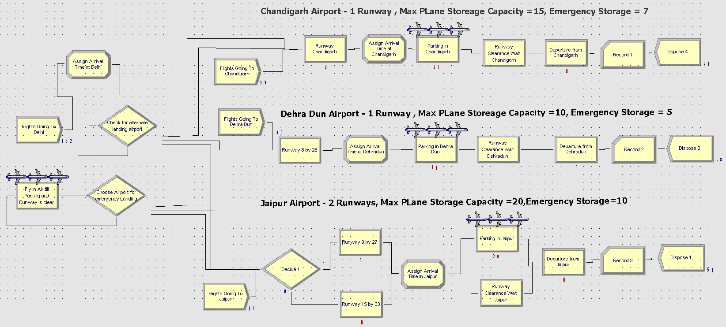
Simulation Model
Simulation Details :
The replication length of the simulation was 1 day and a total of 30 replications were performed on the model.

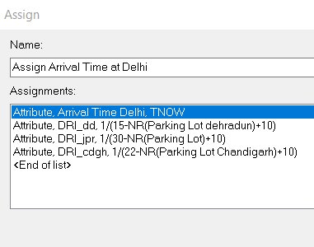
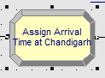
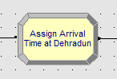
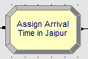
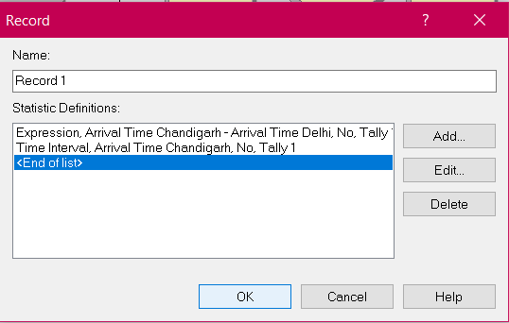
Each flight was assigned an arrival time and DRI for the airports , when it crosses Delhi airport .Later, when they reach at the diverted airport , their arrival time is again stored .This is used to calculate and record the delay of the flight in landing. After the departure of each flight back , we record the delay time and the inter-arrival time of the flights.
The choice for choosing diversion airport was made using a N-way by condition decide module. The conditions for choosing the airports are as follows –
- Chandigarh -- Runway Chandigarh.WIP == 0 && Parking in Chandigarh.WIP<=20
- Dehra Dun -- Parking in Dehra Dun.WIP<=13 && Runway 8 by 26.WIP == 0
- Jaipur -- (Runway 9 by 27.WIP==0 || Runway 15 by 33.WIP == 0) && Parking in Jaipur.WIP<17

The conditions for choosing airport for emergency landing, based on DRI –
- Chandigarh -- (DRI_cdgh < DRI_dd && DRI_cdgh < DRI_jpr ) && Parking in Chandigarh.WIP < 20
- Dehra Dun -- (DRI_dd < DRI_cdgh && DRI_dd < DRI_jpr) && Parking in Dehra Dun.WIP<15
- Jaipur -- (DRI_jpr < DRI_cdgh && DRI_jpr<DRI_dd ) && Parking in Jaipur.WIP<=28
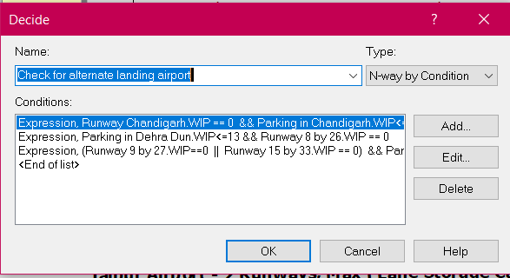
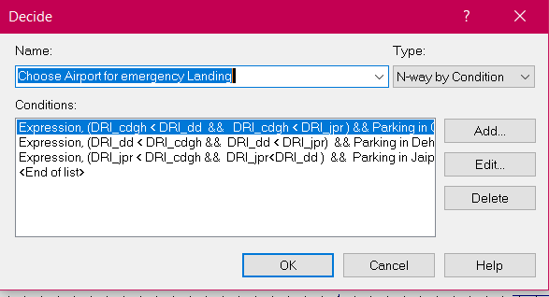

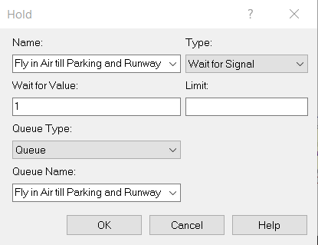
A Hold module is also added , in case emergency landing is not currently possible. This module indicates the process that airplanes will fly in the air till constraints of emergency landing are not satisfied. Planes can fly for an additional 10-20 hrs using their fuel reserves. This module is required as most of the time , the airport facilities such as runways and parking are occupied by flights landing their due to normal schedule. Hence , emergency landing might not be possible at the time and the flights have to wait mid-air.

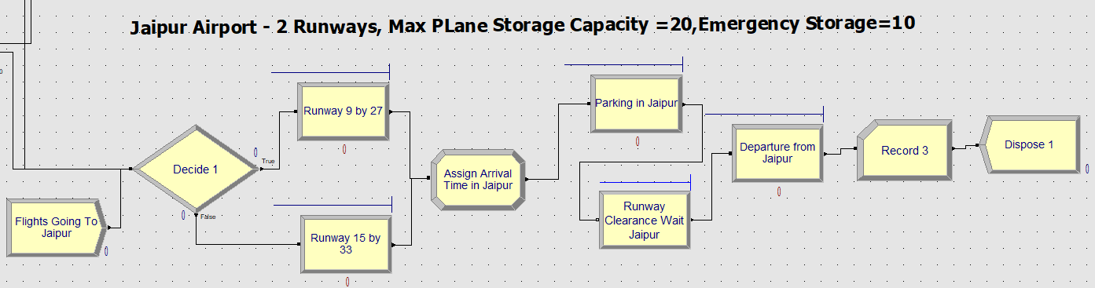
Jaipur Airport
After arriving and parking in the parking space , the flights which are about to depart are queued based on the runway clearance wait module , which checks the utilization status of the runway.
Condition to check : (STATE(Runway 9by27)==IDLE_RES) || (STATE(Runway 15by33 ) == IDLE_RES)
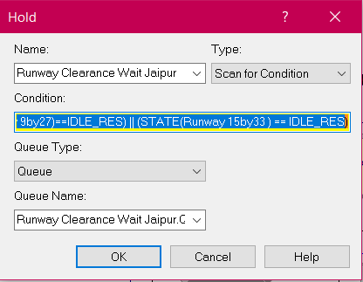

Dehradun Airport
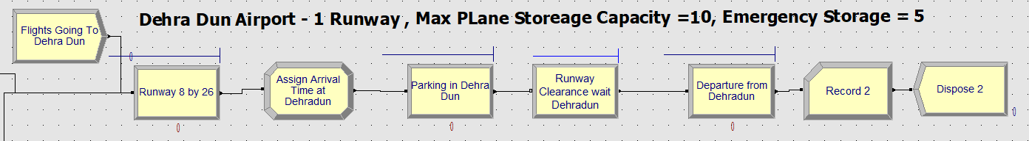
Chandigarh Airport
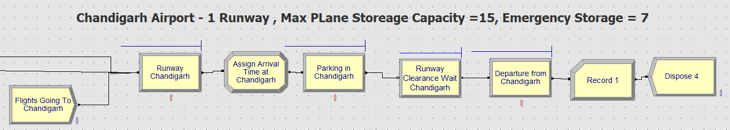

Results:

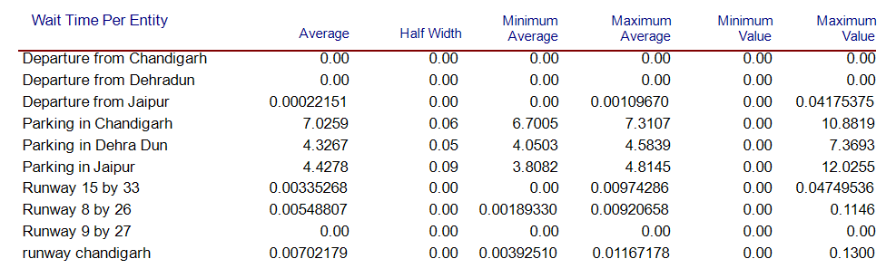
We can observe that the average wait time for parking of a flight is highest in Chandigarh followed by Jaipur and Dehradun. This means the parking space in Chandigarh is very busy and accommodating the diverted flights from Delhi makes the parking system more clogged up and thus , the high wait time is observed. Average waiting time in Jaipur and Dehradun is quite same implying that utilization of parking space is quite similar.
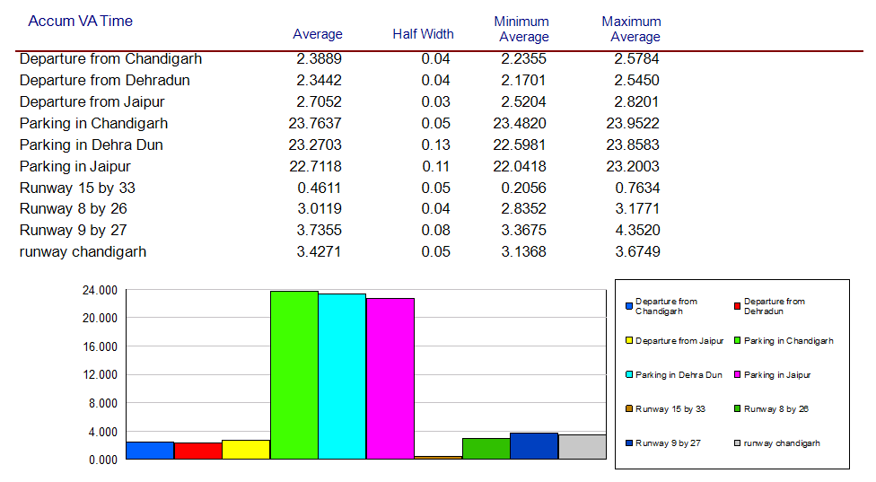
From above graphs , it can be seen that all parking spaces are busy for most time of the day

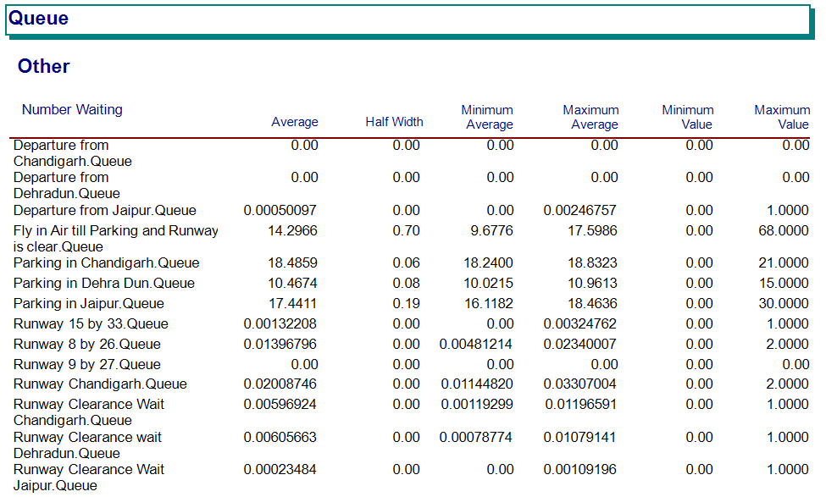

From above results , it is inferred that Chandigarh airport has highest no. of planes in queue due to higher wait time as seen earlier. Although Dehradun has similar no. of planes in queue , its wait time is lower due to faster maintenance and its busy schedule.
Moreover we can see that 14 planes on an average need to fly for additional duration due to non-availability of parking or runway resources during emergency landing.
We can observe below that Parking in Chandigarh is heavily utilized almost completely, followed by Dehradun and Jaipur.
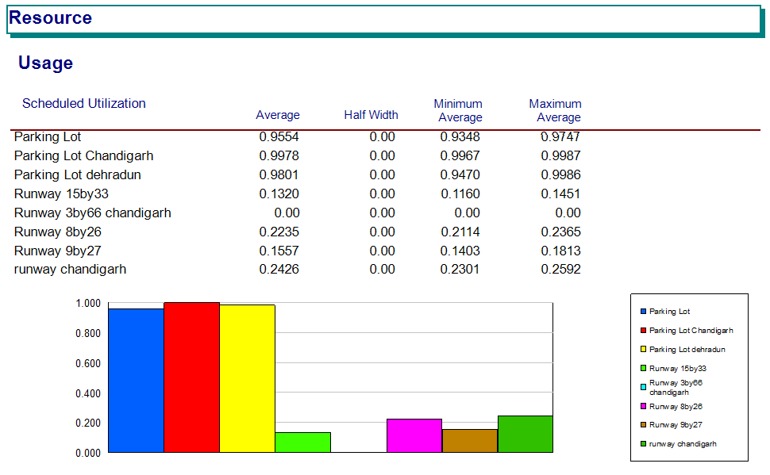

Airports | Average | Runway | Avg. % of Diverted Flights landed
 | Wait-time | utilization
Chandigarh | 7.02 | 99.7% | 33.71%
Dehradun | 4.32 | 98.01% | 26.53%
Jaipur | 4.42 | 95.54% | 39.7%

Inference and Conclusion:

- Most of the diverted flights go to Jaipur followed by Chandigarh and then Dehradun.
- Runway Utilization of Chandigarh is highest and average wait time is also very high , hence it should not be given much priority while choosing airport for diverging route.
- Runway Utilization of Dehradun is high and wait time is smaller as compared to Chandigarh , hence it is more preferable than Chandigarh airport
- Although Chandigarh and Dehradun are less busy in comparison to Jaipur , their runway utilization and wait time is high. This is because of the higher time taken during parking and maintenance and lack of resources to accommodate a large no. of diverted flights.
- Jaipur airport is the most preferred destination due to comparatively lower runway utilization, hence waiting time is lower. Although Jaipur is one of the most busiest airports in India still most planes diverted there. This is result of the fast maintenance and post landing activities , which allow accommodation of more planes.
- Thus the priority for divergence suggested after inference from above results is – Jaipur, Dehradun, Chandigarh. The priority suggested can be overridden at times depending on the diversion risk index at the moment.

